Enterprise SaaS Platform Delivery & Product Leadership

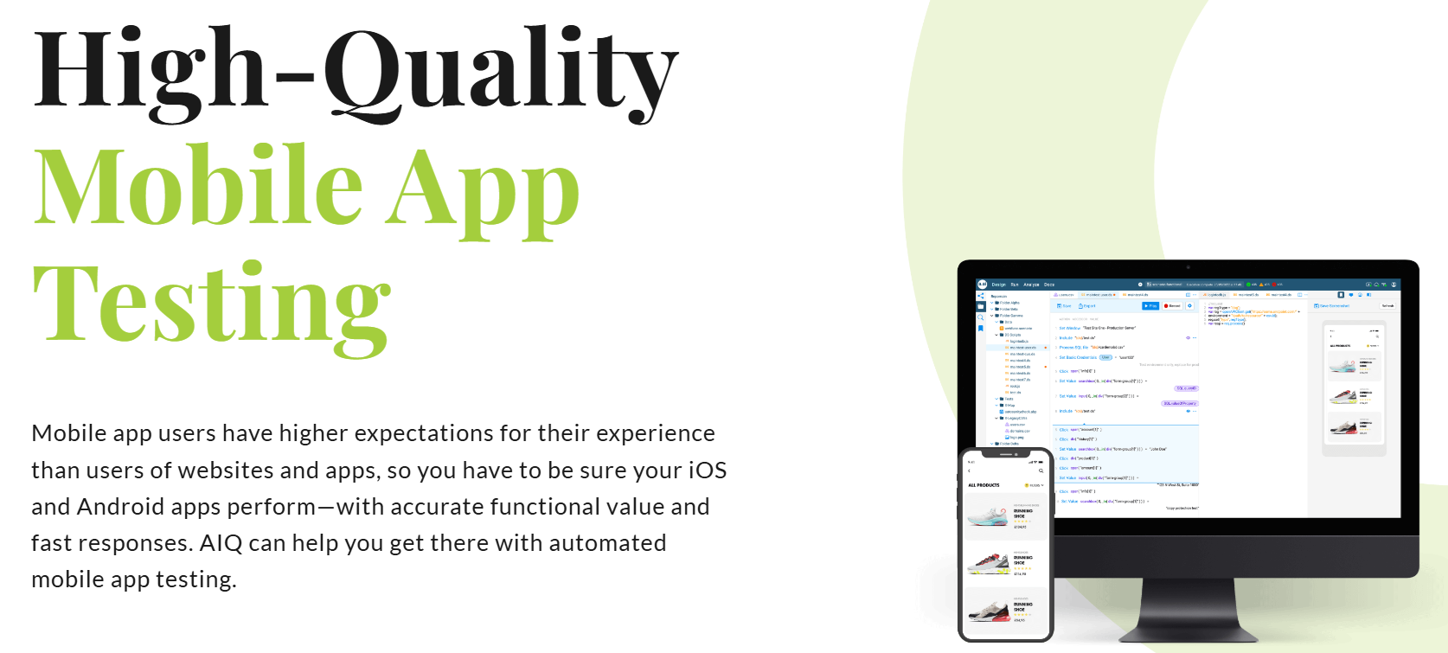

My role. Technical Product Manager / Systems Engineering Lead
Project description:
Led Agile delivery of enterprise SaaS platforms across cross-functional engineering and QA teams. Managed product backlog, user stories, sprint planning, and stakeholder alignment while supporting AI-driven automation and system integration initiatives. Collaborated with technical and business teams to improve software quality, delivery efficiency, and platform reliability through KPI-driven continuous improvement and scalable product execution.
Skills and deliverables
- Product Management
- SaaS
- Artificial Intelligence
- Agile Project Management
- Test Automation

